Teacher’s Notes

Cato’s Can Can

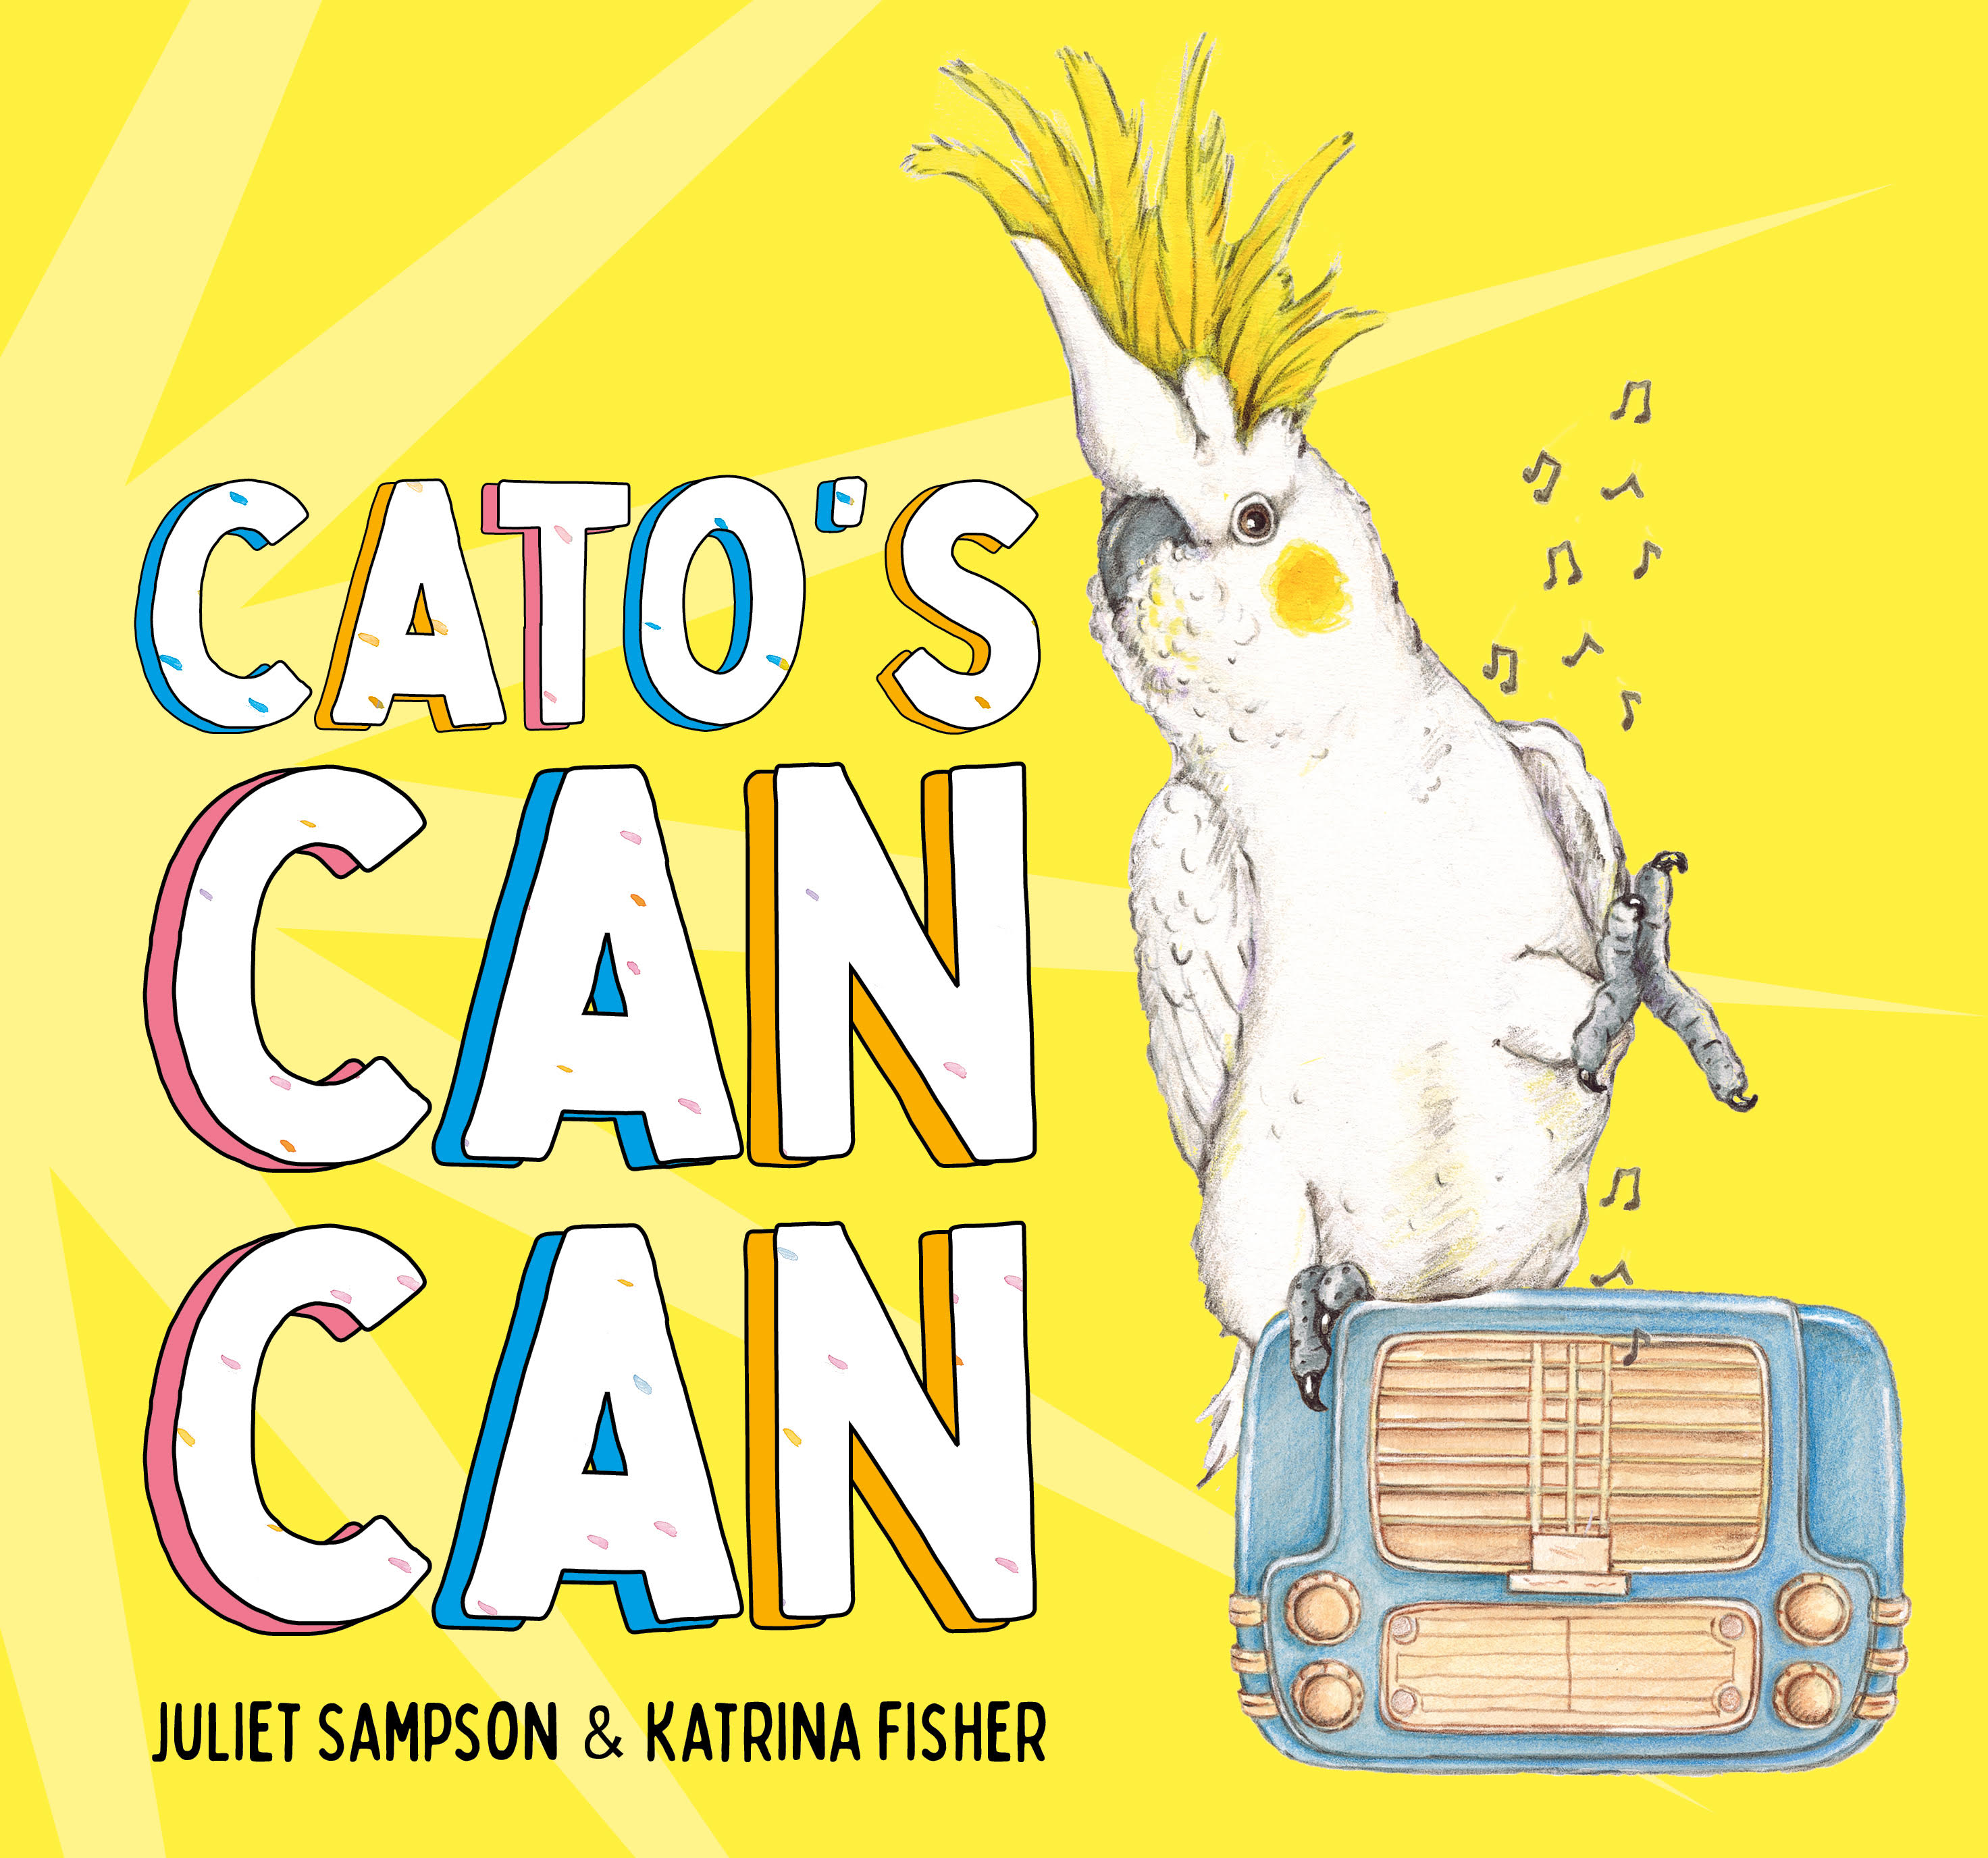

Author: Juliet Sampson

Illustrator: Katrina Fisher

Publisher: Ford Street Publishing

Target Audience: 3 – 7 years

Synopsis:
Bop! Bop! Bop! Hop! Hop! Hop! Cato the cockatoo loves to dance. But he can’t find a friend. That is, until the day he follows some dancers inside … then everyone’s in for a big surprise!

About the Author:
Juliet Sampson is an international award-winning author for children and young adults. Her picture book Grace’s Mystery Seed was a Finalist in the International Book Awards and was shortlisted for the Speech Pathology Award. She has worked as a primary teacher but now dedicates her days to full-time writing.

Also by Juliet Sampson
- Grace’s Mystery Seed
- Outback Wonder
- Dance Demons
- Bon Voyage!
- Behind the Mask

For more information
Website: www.julietmsampson.com.au
Facebook Author’s Page: @JulietMSampson
Instagram: julietmsampsonauthor
Twitter: Juliet M Sampson
Youtube: Juliet M Sampson
Goodreads: Juliet M Sampson

Author’s Inspiration:
Cato’s Can Can was inspired by my passion for dance. I started dancing at the age of eleven. I’ve learnt jazz, tap, ballet, contemporary, funk and Latin American just to name a few.

When writing Cato’s Can Can, I wanted to celebrate the joy of dance. Movement words I chose represented the different styles of dance, spin, bop, snap, leap, tap and hop.

I also love birds and have had many encounters with them all around the world. An eagle in Mongolia, a macaw in Hawaii and a toucan in Brazil but my biggest passion lies with Australian birds, especially the cockatoo. I love its cheeky personality and intelligence.

I hope Cato’s Can Can will fly into the hearts of many readers.

About the Illustrator:

Katrina is a children’s book illustrator based on the beautiful Bellarine Peninsula, in south west Victoria. Drawing and painting has been her passion since childhood, and she has always adored picture books. She studied a degree in visual arts and a post graduate degree in visual communication design. Katrina enjoys creating her picture books using traditional methods such as watercolour paint and pencil on watercolour paper.

Katrina enjoys teaching art to children and conducts art workshops for primary aged children across the region.

Also by Katrina Fisher
- A House of Mud (written by Sophie Masson)
- The Perfect Puppy (written by Alyce Hall)

For more information
Website: www.katrinafisherillustration.com
Facebook Page: @Katrina Fisher Illustration
Instagram: katrinafisher_art

Illustrator’s Inspiration:

I was very excited to illustrate this wonderful story as I adore birds! My inspiration for Cato’s Can Can came from my love of birds and in particular my love of Cockatoos.

As a child, I grew up with a Sulphur Crested Cockatoo called Matilda. She was our family pet. Matilda loved to ride along on the handlebars of my bike. She was a character! Matilda now lives out her days at a beautiful wildlife sanctuary in Barwon Heads.

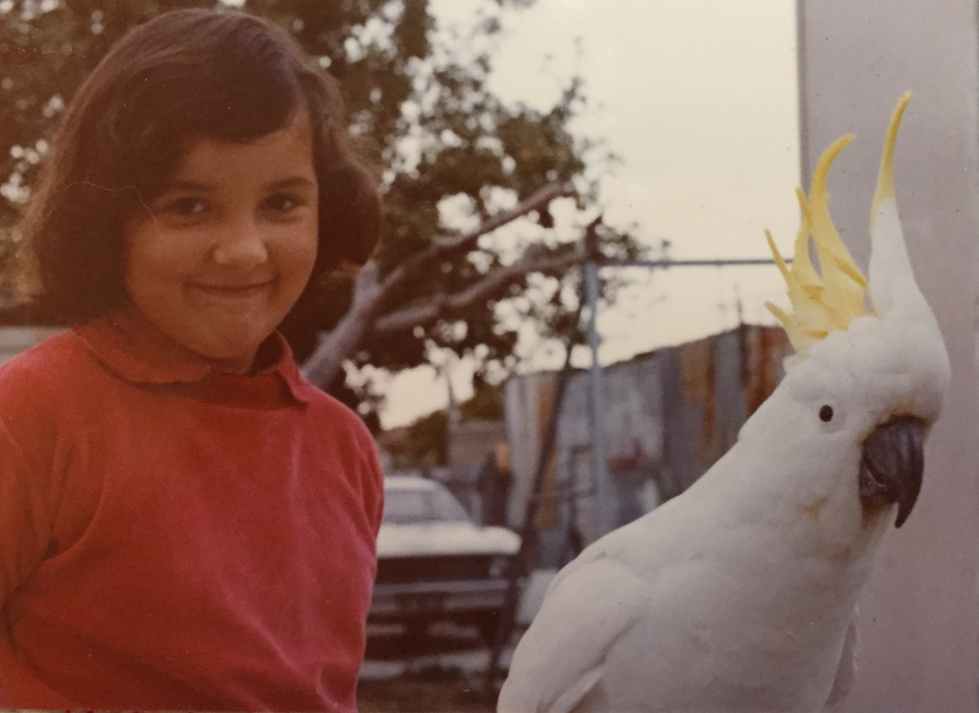

I enjoyed creating Cato and illustrating the interesting behaviours of the cockatoo. They are such inquisitive and animated birds, and they love to dance!

In preparing to illustrate Cato’s Can Can, I researched each bird and took note of their individual characteristics/dance movements. This ensured that I correctly represented them in my drawings. I also spent time researching each dance style and the costumes for the children in the book. This was a fun process.

After completing a storyboard and black/white rough drawings for the book, I prepared the final artwork on watercolour paper, using watercolour paint and pencils.

First stage: initial storyboard drawings

Second stage: black/white roughs

Final stage: painted artwork (watercolour and pencil on paper)

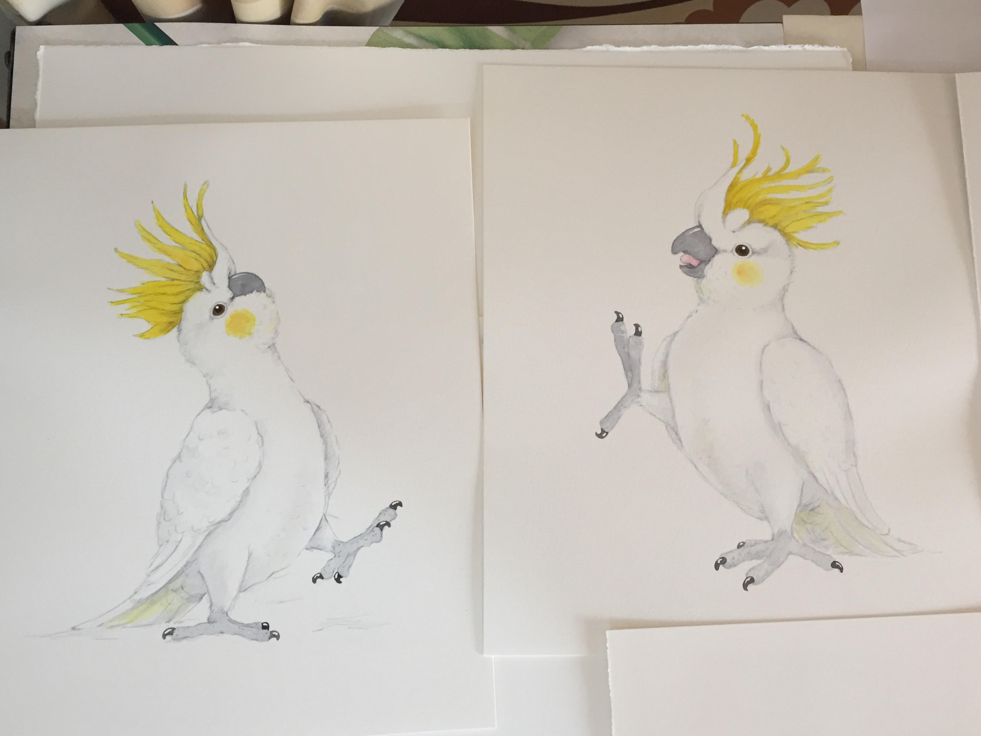

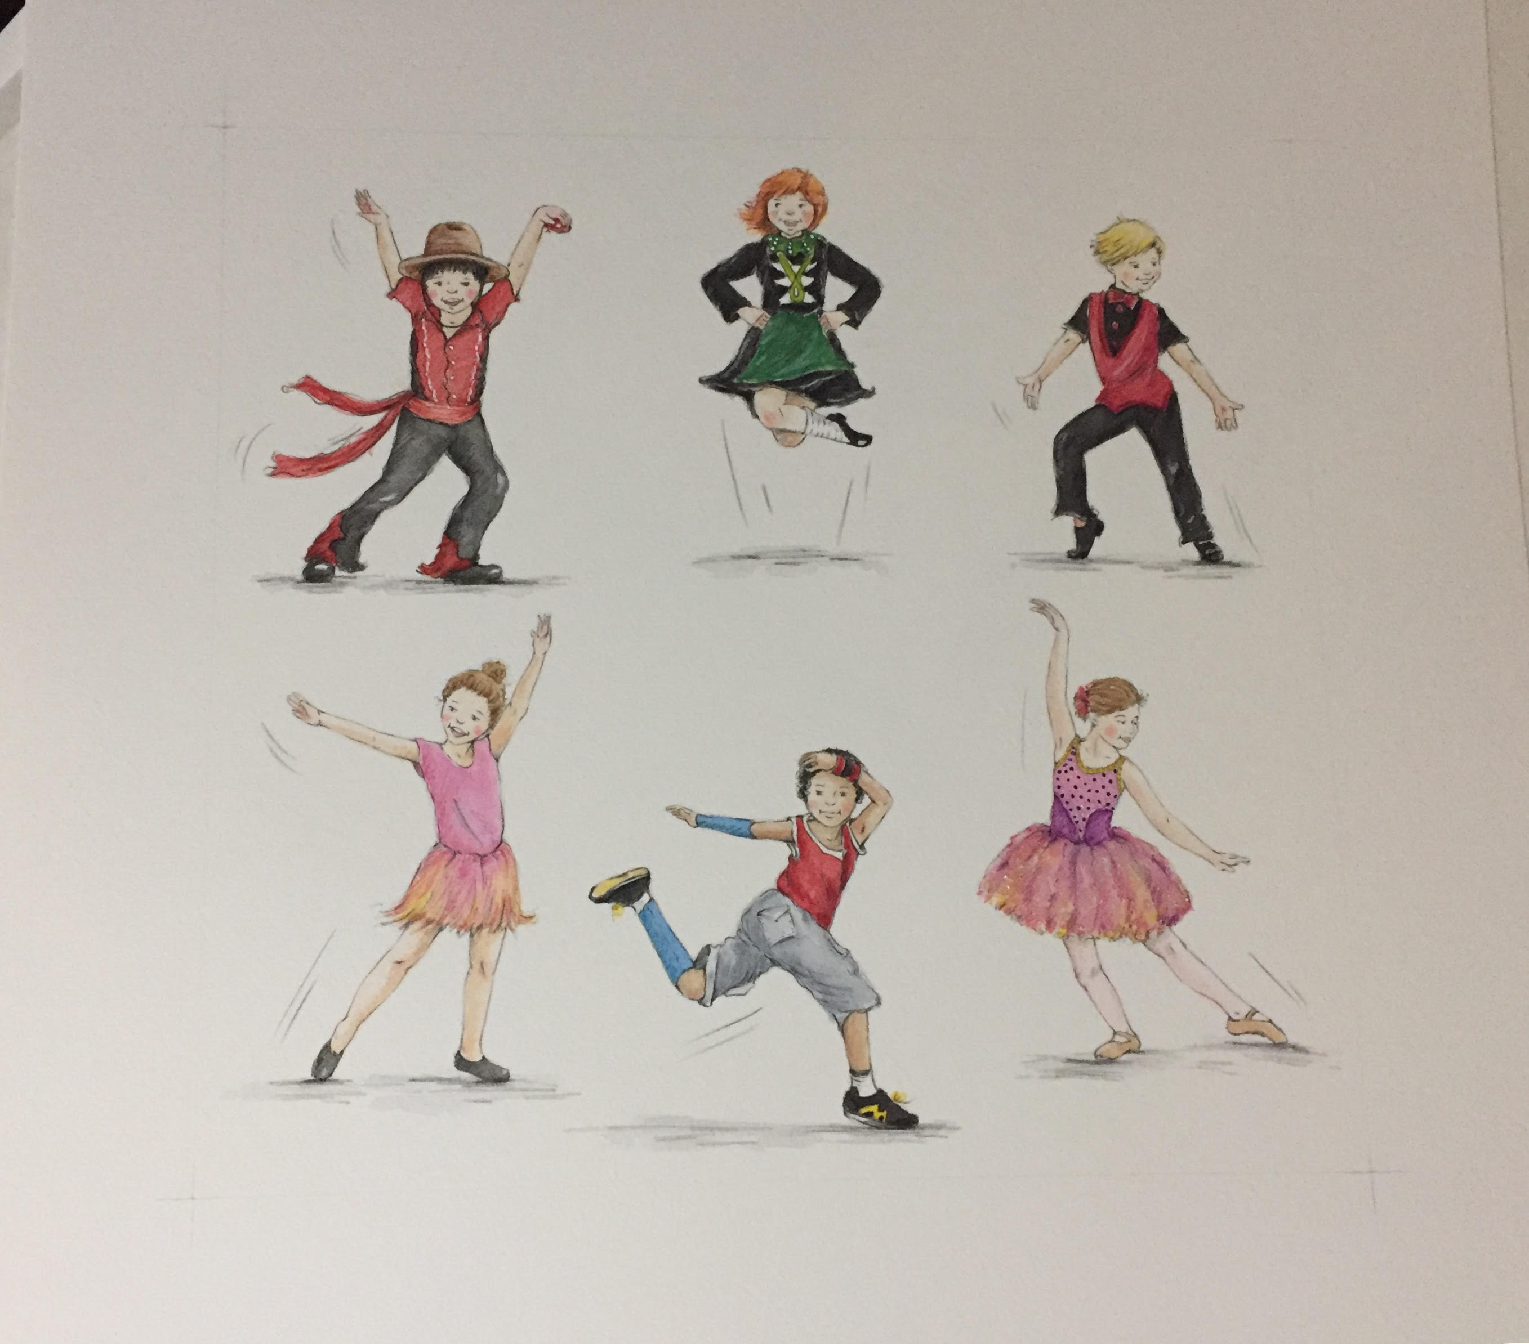

Themes: Loneliness, Bravery, Perseverance, Resilience, Confidence, Friendship and Happiness.

Key points:

- Movement words will help children learn how to dance.
- Laughter, movement and entertainment will encourage children to try different dance styles.
- Promotes the importance of resilience – the capacity to persevere, be brave, overcome fear and develop confidence.
- Introduces children to various dance styles and costumes.
- Children will be introduced to a variety of Australian native birds that can be explored in further study and discussion.
- Children will learn the days of the week and some counting.
- Parents, grandparents and friends will love the shared experience about being brave, overcoming fear and developing confidence.
- Covers many curriculum areas: English, Mathematics, Science, The Arts/ Dance/Drama/Music/Visual Arts/Media Arts and Health and Physical Education.

CLASSROOM IDEAS: DISCUSSION QUESTIONS AND ACTIVITIES

ENGLISH: (Ref: Australian Curriculum – Content Descriptions)
ACELY1660: Use comprehension strategies to build literal and inferred meaning about key events, ideas and information that they listen to, view and read by drawing on growing knowledge of context, text structures and language features.

ACELT1557: Recognise that texts are created by authors who tell stories and share experiences that may be similar or different to students’ own experiences.

- From looking at the front cover, what do you think the story is about?
- What do you think the bird is doing on the front cover?
- What birds do you know? (E.g. seagull, magpie)
- What do they look like?
- Can you name any Australian birds?
- What type of bird is Cato?
- Do you think this is a happy or sad story? Why?
- Do you dance?
- Can you name any dance styles? (E.g. jazz, ballet, tap and hip hop)
- What do we call the person who writes the story? (Author)
- What do we call the person who draws the pictures? (Illustrator)
- What is a blurb?
- Why do we have a blurb?

ACELA 1786: Explore the different contribution of words and images to meaning in stories and informative texts.
- What words are used in Cato’s Can Can to represent birds and movement?
- What words are used in Cato’s Can Can to represent dance and movement?
- What different images (shoes and clothes) are used to represent the dancers?

ACELT1783: Share feelings and thoughts about the events and characters in the story.

ACELT 1582: Discuss characters and events in a range of literary texts and share personal responses to these texts, making connections with students’ own experiences.

ACELT1578: Identity some features of texts including events and characters retell events from a text.

- Do you think Cato is lonely? In what ways?
- When have you felt lonely?
- Do you think Cato is brave? In what ways?
- When did you feel brave?
- Do you think Cato likes to dance? Why?
- Do you like to dance?
- Does dancing make you feel happy? Why?
- What do you like about dancing?
- What shoes might you wear to a dance class?
- Do you think Cato learns something new by the end of the story?
- Do you think the dancers learn something new by the end of the story?
- What is something new that you have learnt?
- How are birds and dancers the same?
- How are birds and dancers different?
- Do you like birds? Why?
- Which birds do you like? And why do you like them?
- How do birds move?
- How do dancers move?
- What happens to Cato at the end of the story?

ACELA1462: Identify language that can be used for appreciating texts and the qualities of people and things.

- How is language used to show movement with the birds? E.g. Bop, bop, bop.
- What language is used to represent dance movements? E.g. Leap, leap, leap.
- Ask students to use different words to describe how Cato feels at the beginning of the book and then at the end of the story.
- Make a list of movement words with students.

ACELA1786: Explore the different contribution of words and images to meaning in stories and informative texts.

- How might a jazz dancer move? (Can repeat for all dance styles.)
- Do you think ballet dancers leap?
- Do you think tap dancers tap?
- Do you think hip-hop dancers spin? (Use for all dance styles.)
- Do you think lorikeets bop? (Use for all birds.)
- What is your favourite illustration and why?
- Why is some of the language repeated in the book?

ACELA1451: Identify the parts of a simple sentence that represents ‘What’s happening?’ What state is being described?’, ‘Who or what is involved?’ and surrounding circumstances.

- Give examples of what happens to Cato before he goes inside the dance studio.
- How does Cato react when seeing the children dancing?
- Explore how movement words are used to represent different types of birds and dancers.

ACELT1584: Discuss features of plot, character and setting in different types of literature and explore some features of characters in different texts.

- Plot: Discuss what happens to Cato, first at the beginning of the story, middle and end.
- Does Cato find what he is looking for?
- Ask students what they think will happen next after the last page.
- Write a book review about Cato’s Can Can.

ACELT1582: Discuss characters and events in a range of literacy texts and share personal responses to these texts, making connections with students’ own experiences.

- Do you like birds?
- What other stories do you know about birds?
- Where have you seen birds?
- Do you have a pet bird?
- Have you seen any of the Australian birds in the book in real life?
- Have you ever needed to be brave like Cato?
- Have you ever learnt a new dance like Cato and the children in the story?
- Do you go to a dance school? If so what dances do you learn?
- What types of shoes does a tap dancer wear? (Ask this question for all dance styles.)

ACELA1453: Compare different kinds of images in narrative and informative texts and discuss how they contribute to meaning.

- How do the images depict Cato’s personality and what he is experiencing?
- From the images how do you think the children are feeling when they are dancing?
- How do the children dance in Irish class? E.g. Hop
- How do the children dance in tap? E.g. Tap
- How does the lyrebird move? Look at the image. (Repeat this activity for all the Australian birds in Cato’s Can Can.)

MATHEMATICS: (Ref: Australian Curriculum – Content Descriptions)

ACMMG007: Compare and order duration of events using everyday language of time.

ACMMG008: Connect days of the week to familiar events and actions.

ACMNA001: Establish understanding of the language and processes of counting by naming numbers in sequence, initially to and from 20, moving from any starting point.

- Identify the different days of the week in Cato’s Can Can.
- What Australian bird is spotted on a Monday? E.g. A lyrebird. Repeat for all the days of the week.
- How many dancers does Cato see on a Monday? (Use this question for each of the days of the week. E.g. On Friday, he sees five dancers.
- What might you do on a Monday? E.g. Go to school? Go to a dance class? Go to a piano lesson? Go to swimming lessons?

SCIENCE: (Ref: Australian Curriculum – Content Descriptions)

ACSSU002: Living things have basic needs, including food and water.
- What do birds need to survive? E.g. food and water.
- What do birds eat?
- What do cockatoos eat?
- Where do cockatoos live?

ACSSU017: Living things have a variety of external features.
- What type of bird is Cato?
- What are the physical features and characteristics of birds? E.g. wings, beak
- List some Australian birds similarities and differences.
- Why do birds need wings? E.g. To fly (movement)
- Look at different birds. See similarities and differences.

VISUAL ARTS/CRAFT: (Ref: Australian Curriculum – Content Descriptions)

ACAVAM107: Use and experiment with different materials, techniques, technologies and processes to make artworks.

- Make a cockatoo bird puppet with a brown paper bag.
- Make dance puppets representing different dance styles.
- Draw/paint different dance costumes and shoes.
- Use magazines and create different picture of Australia birds.
- Make a clay/playdough bird.

MUSIC: (Ref: Australian Curriculum – Content Descriptions)

ACAMUM081: Sing and play instruments to improvise, practise a repertoire of chants, songs and rhymes, including songs used by cultural groups in the community.

ACAMUM082: Create compositions and perform music to communicate ideas and audience.

- What instruments could you use to represent the different movement words in Cato’s Can Can? E.g. Leap, leap, leap = a triangle. Snap, snap, snap = castanets. Hop, hop, hop = wood block.
- Use the words in Cato’s Can Can to create a song.
- Combine instruments and words of the song to put together a performance.
- Use different instruments to represent various Australian birds.
- Create your own ‘new dance style’ with your own music.
- Learn the Can Can and the music associated with the dance.

DANCE: (Ref: Australian Curriculum – Content Descriptions)

ACADAM001: Explore, improvise and organise ideas to make dance sequences using elements of dance.

ACADAM002: Use fundamental movement skills to develop technical skills when practising dance sequences.

ACADAM003: Present dance that communicates ideas to an audience, including dance used by cultural groups in the community.

- Improvise being Cato, bopping, rocking, stomping and kicking.
- Improvise dance ideas for example, flying like a bird, spinning like a lyrebird, bopping like a lorikeet, snapping like riflebirds, leaping like brolgas and tapping like grebes.
- Improvise dancing: Like hip-hop dancers: spin, spin, spin, like jazz dancers: bop, bop, bop, like flamenco dancers: snap, snap, snap, like ballet dancers: leap, leap, leap, like tap dancers, tap, tap, tap and like Irish dancers hop, hop, hop.
- As a class learn about the Can Can moves and the music used with this dance style.
- What might you wear if you are a tap dancer? Costume and shoes. (Use question for each type of dance style.)
- What type of dance requires slow music? E.g. Ballet
- What type of dance requires fast music? E.g. Jazz
- Which type of dance requires slow movements?
- Which type of dance requires fast movements?
- Improvise slow movements. E.g. crawling
- Improvise fast movements. E.g. jumping
- Make up a new dance for Cato.

DRAMA: (Ref: Australian Curriculum – Content Descriptions)

ACEL1787: Explore different ways of expressing emotions, including verbal, visual, body language and facial expressions.

ACADRM027: Explore role and dramatic action in dramatic play, improvisation process drama.

- Act out the story of Cato’s Can Can.
- Pretend to be Cato when he is lonely, brave and happy. Discuss the different emotions, body language and facial expressions.

HEALTH and PHYSICAL ED: (Ref: Australian Curriculum – Content Descriptions)

ACPMP008: Practise fundamental movement skills and movement sequences using different body parts.

- Use the movement words in Cato’s Can Can. E.g. leap, hop, bop. Then link them to physical activities like hop scotch, jump rope (skipping), hopping on one leg and bouncing a ball.
- Discuss the word ‘kick’. What you need to do to kick a ball. What parts of the body you use.
- Leap over a hurdle or a person’s back (leap frog). Different to jumping into a sand pit for long jump.
- Talk about different body parts you need to use to create the movement.

Message from Juliet and Katrina.

Cato hopes to fly into the hearts of readers. Happy dancing!

